**ORGAN DONATION MANAGEMENT REPORT**

**INTRODUCTION**

Organ transplantation is the surgical removal of an organ or tissue from one person (the donor) and placing it in another person (the recipient ). Organ donation is when you allow your organs or tissues to be removed and given to someone else. Most donated organs and tissues are from people who have died. But a living person can donate some organs. Blood, stem cells, and platelets can also be donated. There’s no age limits on who can be an organ donor. New-born’s as well as senior citizens have been organ donors. If you are younger than 18 years old, you must have a parents or guardian’s consent. If you are 18 years or older, you can you can show you want to be an organ and tissue donor by signing a donor card.

**PROBLEM STATEMENT**

Lack of an appropriate organ donor is a frequent problem faced by the people. This can be overcome if deceased organ donation is implemented in a proper manner.

India has only 301 hospitals that can perform organ transplantation. Out of which 250 have registered with NOTTO (National Organ and Tissue Transplant Organization). Which means to conduct an organ transplant, there exist one fully equipped hospital for around 43 lakh people.

Lack of education awareness among general public about organ donation, organ donation cards, process of organ donation add to the superstitions and misconceptions associated with organ donation in our country and make the organ donation a tedious task.

Every ten minutes, someone is added to the national transplant waiting list. On average 20 people die each day while waiting for transplant.

**EXISTING SYSTEMS**

* Godrej HIT
* NHS Organ Donation
* [www.donatelifeindia.org](http://www.donatelifeindia.org)

These are the apps for online registration as an organ donor.

Mainly it is required to create awareness to contribute to save people’s lives.

There are only 0.16 organ donors per million people in India.

One donor could save not 1, but 8 lives at a time. A tissue donor can save 50 lives.  As is outlined in this presentation, we strongly believe that the implementation of these pathways for obtaining organs from the living and the dead donors, with appropriate consideration of the ethical, religious and social criteria of the society, the organ shortage crisis will be eliminated and many lives will be saved through the process of organ donation and transplantation. Hence, we require a proper Organ donation management system.

**PROPOSED SYSTEM**

1. Easy for the users to donate and receive organs
2. Avoid the manual work.
3. Becoming a donor is easy.

**HARDWARE INTERFACE**

* We require LAN connection for interacting with data base and local computers for any help or any other requirements. We use TCP/IP protocol for communicating with local hosts.
* Hardware processor: Intel core i5, 7th Gen
* RAM: 4GB DDR4 RAM
* Hard Disk: 20GB or more

**SOFTWARE REQUIREMENT**

1. Software requirements are

2. Operating System : Windows 10

3. Software programming languages used are

* HTML
* Cascading Style Sheet
* PHP
* My SQL database (Wamp Server)

**ENTITY RELATIONSHIP DIAGRAM**

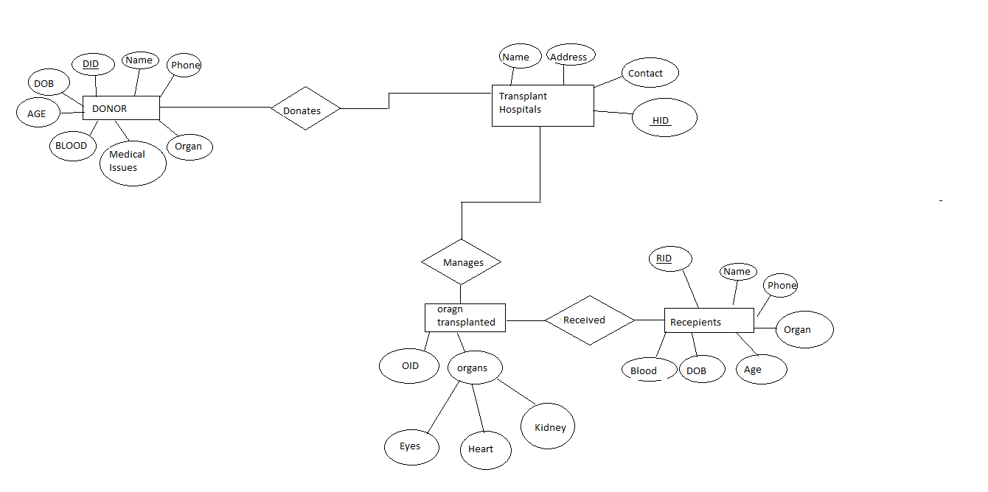

**DATABASE TABLES**

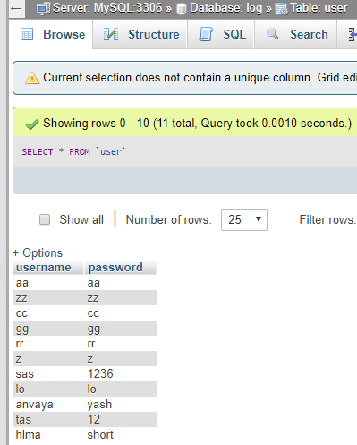

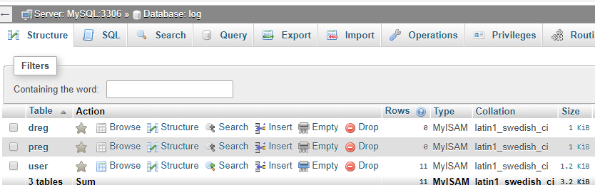

**SOURCE**

[**www.organdonor.gov**](http://www.organdonor.gov)

[**www.ncbi.nlm.nih.gov**](http://www.ncbi.nlm.nih.gov)

[**www.njsharingnetwork.org**](http://www.njsharingnetwork.org)

[www.archive.org](http://www.archive.org)